

Deep Learning

Sir Syed University (NAVTCC)



May 22, 2024

Zameer Ali Tunio

Artificial Intelligence

**Introduction to deep learning**  
Deep learning is a subset of machine learning that uses multi-layered neural networks, called deep neural networks, to simulate the complex decision-making power of the human brain. Some form of deep learning powers most of the artificial intelligence (AI) in our lives today.

**What is neuron?**

Neurons in deep learning models are nodes through which data and computations flow. Neurons work like this: They receive one or more input signals. These input signals can come from either the raw data set or from neurons positioned at a previous layer of the neural net. They perform some calculations.

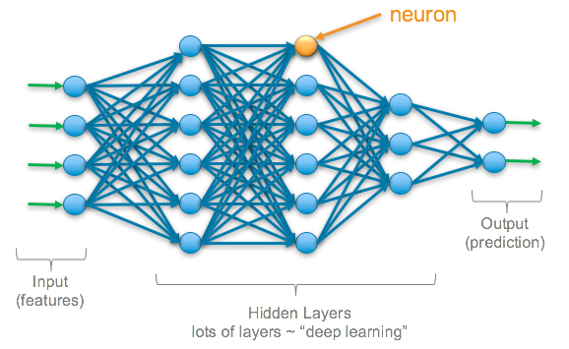

**What is deep learning?**

Deep learning is a method in artificial intelligence (AI) that teaches computers to process data in a way that is inspired by the human brain. Deep learning models can recognize complex patterns in pictures, text, sounds, and other data to produce accurate insights and predictions.

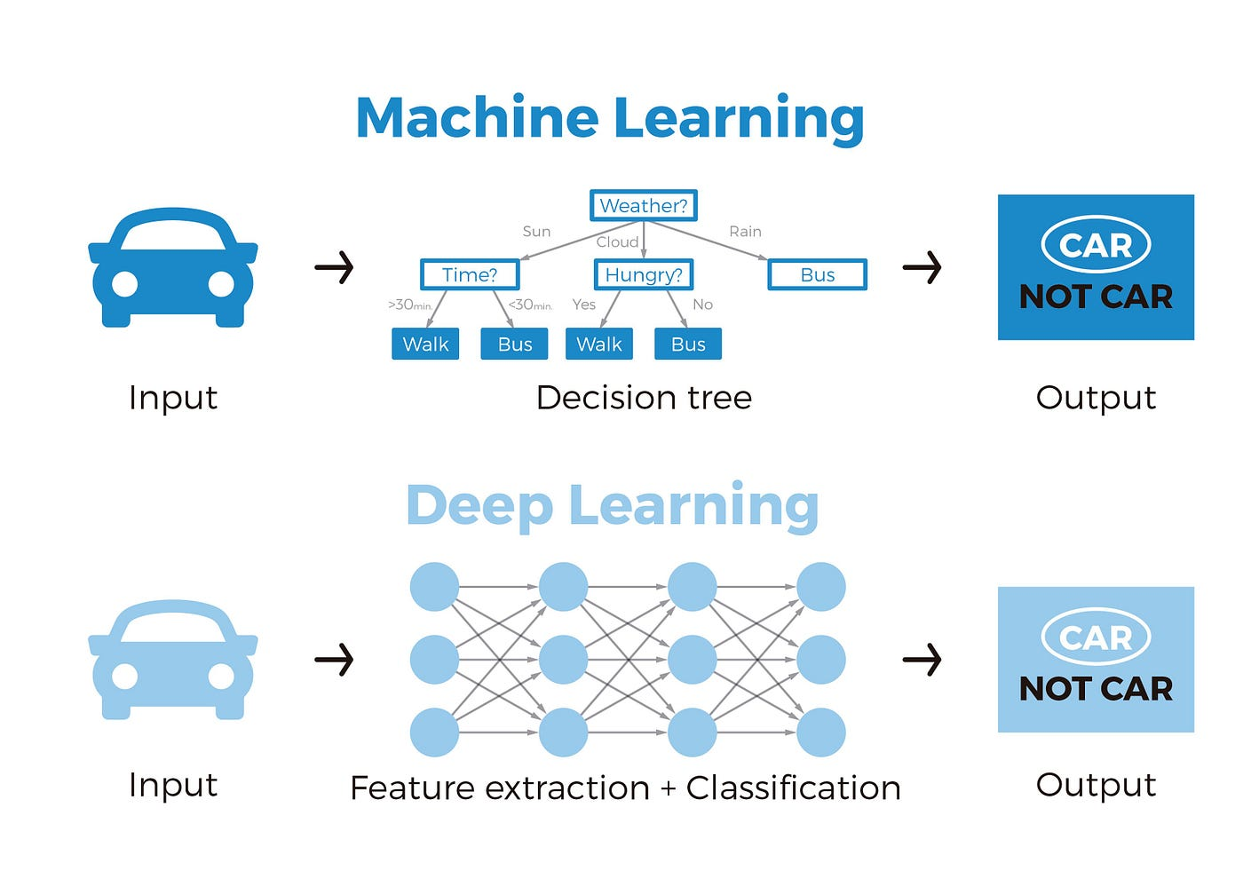

**What is neural networks?**

A neural network is a method in artificial intelligence that teaches computers to process data in a way that is inspired by the human brain. It is a type of machine learning process, called deep learning, that uses interconnected nodes or neurons in a layered structure that resembles the human brain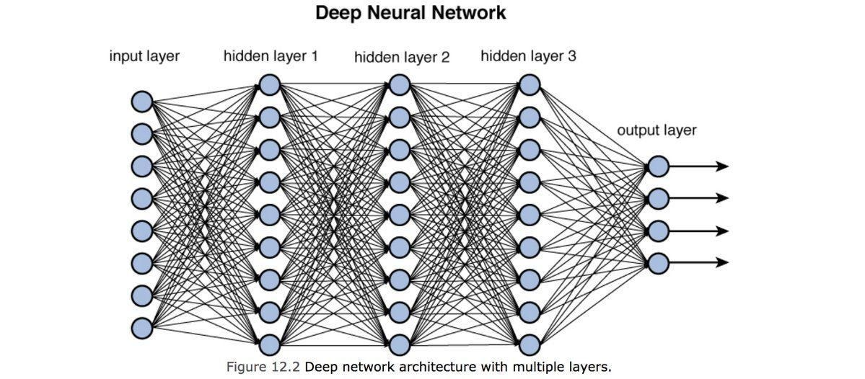

**What is artificial neural network?**

The Artificial Neural Network (ANN) is a deep learning method that arose from the concept of the human brain Biological Neural Networks. The development of ANN was the result of an attempt to replicate the workings of the human brain.

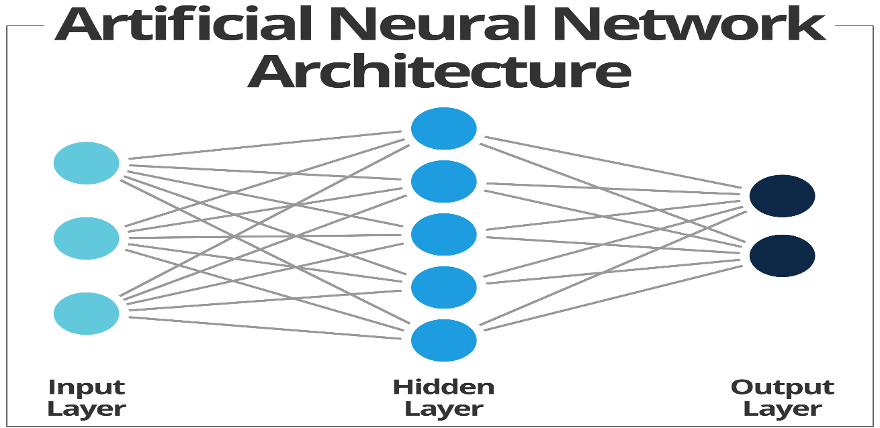

**What is convolutional neural network?**

Within Deep Learning, a Convolutional Neural Network or CNN is a type of artificial neural network, which is widely used for image/object recognition and classification.

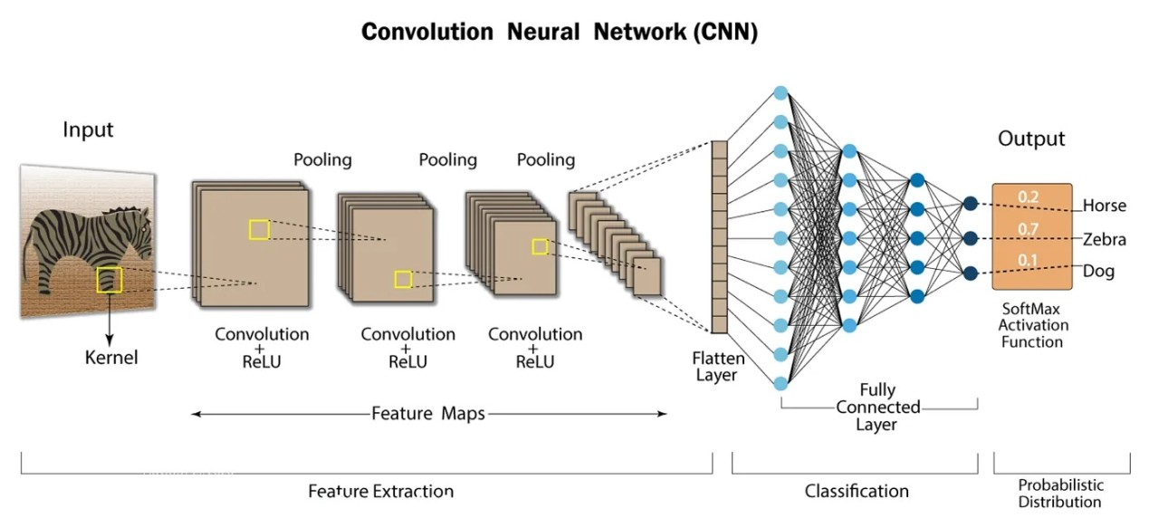

**Difference between ANNs and CNNs?**

ANNs (Artificial Neural Networks) are helpful for solving complex problems. CNNs (Convolution Neural Networks) are best for solving Computer Vision-related problems. They are both unique in how they work mathematically, and this causes them to be better at solving specific problems. In general, CNN tends to be a more powerful and accurate way of solving classification problems. ANN is still dominant for problems where datasets are limited, and image inputs are not necessary. Moreover, ANN cannot capture the sequential information required for sequence data. Thus, CNN would always be a preferred way for dealing with 2D image classification problems because of its ability to deal with images as data, thereby providing higher accuracy.

